Toader Mihai
Grupa: 237

Documentatie laborator 3 ppd

1.Cerinta
Implementati o clasa “SortedLinkedList” – lista inlantuita sortata cu elemente de tip real, astfel incat sa fie “thread-safe”.
Operatiile furnizate de clasa sunt:
- insert(a: Real)
o pre: this=[a(0),…,a(n)] a.i. pentru orice i: 0 a(i-1) <=a(i)<=a(i+1)
o post: a este adaugat in lista pe pozitia corespunzatoare: this=[a(0), …a(i), a, a(i+1)…,a(n)] a.i. a(i) <=a<=a(i+1)
- delete(a: Real)
o pre : exista pos o pozitie valida in lista a.i. lista(pos)= a
o post: elementul a este sters din lista
- getIterator():Iterator
o pre : lista valida
o post: result = it , it in Iterator pe lista Clasa Iterator va fi definita corespunzator cu specificatia clasica a unui iterator (implementeaza interfata IIterator cu operatiile: getNext(); isValid(); getElement()).
Variante
Se cere implementarea a doua variante:
1. sincronizare la nivel de nod sau portiune din lista,
2. sincronizare la nivelul intregii liste.
La testarea iteratorului se va folosi intotdeauna sincronizarea intregii liste.

2. Specificatii
class SortedLinkedListV1<T extends Comparable>
-implementarea listei inlantuite cu sincronizare la nivel de nod

public void add(T value)
-pentru adunare, adaug tot timpul inainte, exceptand cazul cand trebuie sa adaug la final, sau cand nu exista elemente in lista. Pentru a gasi pozitia corespunzatoare blochez nodul curent si nodul urmator. Cand am gasit pozitia pe care trebuie sa inserez, daca acea pozitie se afla in interiorul listei, nodurile intre care trebuie sa inserez sunt deja blocate de la parcurgere. Daca trebuie sa inserez la final, ultimul nod, dupa care trebuie sa fac inserare este de asemenea blocat de la parcurgere.
-daca trebuie sa inserez la final sau inainte de primul element, blochez doar primul, respectiv ultimul element.

public T delete(Integer pos)
-pentru stergere, caut nodul de pe pozitia data blocand nodul curent. Daca nodul de pe pozitia data se afla in mijlocul liste, nodul este deja blocat din parcurgerea anterioara, blochez nodul din dreapta si nodul din stanga, dupa care sterg legaturile si eliberez nodurile.
-daca stergerea este de pe prima pozitie, blochez primul si al doilea nod, iar daca stergerea este de pe ultima pozitie blochez ultimul si penultimul nod.

public String iterate()
-returneza un string care contine elementele listei separate prin spatiu. Pentru salvarea elementelor in string se foloseste un iterator. Aceasta operatie este atomica.

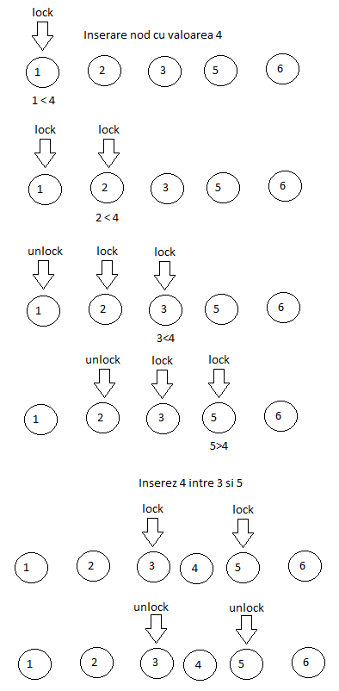
Exemplu adunare in interiorul listei:

Exemplu de stergere din interiorul listei:
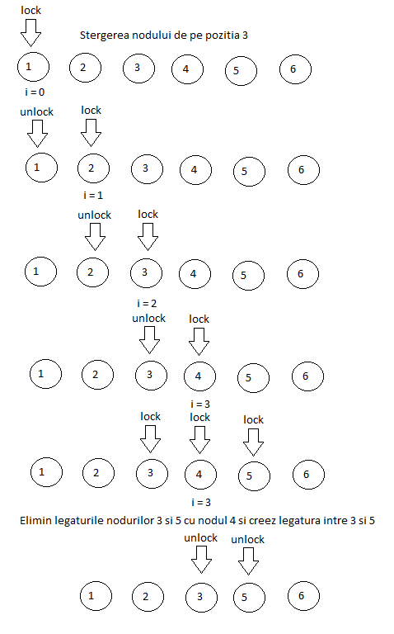

class SortedLinkedListV1<T extends Comparable>
- implementarea listei inlantuite cu sincronizare la nivelul intregii liste
- pentru operatiile de adunare, stergere si iterare, am adaugat
synchronized (this)
-doar un thread poate accesa o metoda in acelasi timp

public class WriteToFile implements Runnable
-aceasta clasa este folosita pentru scrierea logurilor in fisier.
-threadurile ThreadListAdd, ThreadListDelete si ThreadListIterate o primesc ca argument, ThreadListAdd si ThreadListDelete incrementeaza campul used a clasei WriteToFile, iar ThreadListIterate se foloseste de campul used ca sa isi opreasca executia.
-clasa are camp de tip string cu logurile threadurilor. Dupa fiecare executie, threadurile Add, Delete si Iterate, adauga rezultatul in acel camp, accesul threadurilor este sincronizat.

Teste:
Test 1 - Program care porneste 4 threaduri care lucreaza pe aceeasi lista:
o T1 adauga 10 de valori
o T2 adauga 5 de valori
o T3 sterge 7 de valori
o T4 itereaza lista in mod repetat la interval Δt ( ex. de 3s – se alege a.i. sa fie egal cu timpul necesar adaugarii a 3 valori) si se termina dupa ce threadurile T1, T2, T3 se termina.

Timp total: 29ms pentru varianta 1
Log.txt:
[2017-11-13T18:37:38.844 - 2017-11-13T18:37:38.845] # Add # Thread: 2 # Nr operation: 0 # Sec 0 # Millis 1 # Value 10
[2017-11-13T18:37:38.844 - 2017-11-13T18:37:38.846] # Add # Thread: 1 # Nr operation: 0 # Sec 0 # Millis 2 # Value 1
[2017-11-13T18:37:38.845 - 2017-11-13T18:37:38.846] # Iterate # Thread: 4 # Sec 0 # Millis 1 # Values: 1
[2017-11-13T18:37:38.845 - 2017-11-13T18:37:38.845] # Delete # Thread: 3 # Nr operation: 0 # Sec 0 # Millis 0 # Value 10
[2017-11-13T18:37:38.852 - 2017-11-13T18:37:38.852] # Add # Thread: 2 # Nr operation: 1 # Sec 0 # Millis 0 # Value 9
[2017-11-13T18:37:38.853 - 2017-11-13T18:37:38.853] # Add # Thread: 1 # Nr operation: 1 # Sec 0 # Millis 0 # Value 5
[2017-11-13T18:37:38.853 - 2017-11-13T18:37:38.853] # Delete # Thread: 3 # Nr operation: 0 # Sec 0 # Millis 0 # Value 1
[2017-11-13T18:37:38.853 - 2017-11-13T18:37:38.853] # Add # Thread: 1 # Nr operation: 2 # Sec 0 # Millis 0 # Value 10
[2017-11-13T18:37:38.853 - 2017-11-13T18:37:38.853] # Add # Thread: 2 # Nr operation: 2 # Sec 0 # Millis 0 # Value 1
[2017-11-13T18:37:38.854 - 2017-11-13T18:37:38.854] # Add # Thread: 2 # Nr operation: 3 # Sec 0 # Millis 0 # Value 10
[2017-11-13T18:37:38.854 - 2017-11-13T18:37:38.854] # Add # Thread: 1 # Nr operation: 3 # Sec 0 # Millis 0 # Value 7
[2017-11-13T18:37:38.854 - 2017-11-13T18:37:38.854] # Add # Thread: 2 # Nr operation: 4 # Sec 0 # Millis 0 # Value 0
[2017-11-13T18:37:38.854 - 2017-11-13T18:37:38.854] # Add # Thread: 1 # Nr operation: 4 # Sec 0 # Millis 0 # Value 1
[2017-11-13T18:37:38.854 - 2017-11-13T18:37:38.854] # Delete # Thread: 3 # Nr operation: 0 # Sec 0 # Millis 0 # Value 1
[2017-11-13T18:37:38.855 - 2017-11-13T18:37:38.855] # Add # Thread: 1 # Nr operation: 5 # Sec 0 # Millis 0 # Value 5
[2017-11-13T18:37:38.855 - 2017-11-13T18:37:38.855] # Delete # Thread: 3 # Nr operation: 0 # Sec 0 # Millis 0 # Value 1
[2017-11-13T18:37:38.856 - 2017-11-13T18:37:38.856] # Iterate # Thread: 4 # Sec 0 # Millis 0 # Values: 0 5 5 7 9 10 10
[2017-11-13T18:37:38.856 - 2017-11-13T18:37:38.856] # Add # Thread: 1 # Nr operation: 6 # Sec 0 # Millis 0 # Value 6
[2017-11-13T18:37:38.856 - 2017-11-13T18:37:38.856] # Delete # Thread: 3 # Nr operation: 0 # Sec 0 # Millis 0 # Value 0
[2017-11-13T18:37:38.856 - 2017-11-13T18:37:38.856] # Add # Thread: 1 # Nr operation: 7 # Sec 0 # Millis 0 # Value 1
[2017-11-13T18:37:38.856 - 2017-11-13T18:37:38.856] # Delete # Thread: 3 # Nr operation: 0 # Sec 0 # Millis 0 # Value 1
[2017-11-13T18:37:38.856 - 2017-11-13T18:37:38.856] # Add # Thread: 1 # Nr operation: 8 # Sec 0 # Millis 0 # Value 0
[2017-11-13T18:37:38.857 - 2017-11-13T18:37:38.857] # Delete # Thread: 3 # Nr operation: 0 # Sec 0 # Millis 0 # Value 0
[2017-11-13T18:37:38.857 - 2017-11-13T18:37:38.857] # Add # Thread: 1 # Nr operation: 9 # Sec 0 # Millis 0 # Value 1
[2017-11-13T18:37:38.858 - 2017-11-13T18:37:38.858] # Iterate # Thread: 4 # Sec 0 # Millis 0 # Values: 1 5 5 6 7 9 10 10
Timp total: 35ms pentru varianta 2
Log.txt:
[2017-11-13T18:36:28.319 - 2017-11-13T18:36:28.320] # Add # Thread: 2 # Nr operation: 0 # Sec 0 # Millis 1 # Value 5
[2017-11-13T18:36:28.319 - 2017-11-13T18:36:28.322] # Delete # Thread: 3 # Nr operation: 0 # Sec 0 # Millis 3 # Value 5
[2017-11-13T18:36:28.319 - 2017-11-13T18:36:28.322] # Add # Thread: 1 # Nr operation: 0 # Sec 0 # Millis 3 # Value 8
[2017-11-13T18:36:28.320 - 2017-11-13T18:36:28.322] # Iterate # Thread: 4 # Sec 0 # Millis 2 # Values: 5
[2017-11-13T18:36:28.329 - 2017-11-13T18:36:28.329] # Add # Thread: 2 # Nr operation: 1 # Sec 0 # Millis 0 # Value 7
[2017-11-13T18:36:28.329 - 2017-11-13T18:36:28.329] # Add # Thread: 1 # Nr operation: 1 # Sec 0 # Millis 0 # Value 10
[2017-11-13T18:36:28.329 - 2017-11-13T18:36:28.329] # Add # Thread: 2 # Nr operation: 2 # Sec 0 # Millis 0 # Value 2
[2017-11-13T18:36:28.329 - 2017-11-13T18:36:28.329] # Add # Thread: 1 # Nr operation: 2 # Sec 0 # Millis 0 # Value 0
[2017-11-13T18:36:28.330 - 2017-11-13T18:36:28.330] # Add # Thread: 2 # Nr operation: 3 # Sec 0 # Millis 0 # Value 6
[2017-11-13T18:36:28.329 - 2017-11-13T18:36:28.329] # Delete # Thread: 3 # Nr operation: 0 # Sec 0 # Millis 0 # Value 8
[2017-11-13T18:36:28.330 - 2017-11-13T18:36:28.330] # Add # Thread: 1 # Nr operation: 3 # Sec 0 # Millis 0 # Value 9
[2017-11-13T18:36:28.330 - 2017-11-13T18:36:28.330] # Add # Thread: 2 # Nr operation: 4 # Sec 0 # Millis 0 # Value 0
[2017-11-13T18:36:28.330 - 2017-11-13T18:36:28.330] # Delete # Thread: 3 # Nr operation: 0 # Sec 0 # Millis 0 # Value 0
[2017-11-13T18:36:28.331 - 2017-11-13T18:36:28.331] # Delete # Thread: 3 # Nr operation: 0 # Sec 0 # Millis 0 # Value 0
[2017-11-13T18:36:28.330 - 2017-11-13T18:36:28.330] # Add # Thread: 1 # Nr operation: 4 # Sec 0 # Millis 0 # Value 6
[2017-11-13T18:36:28.331 - 2017-11-13T18:36:28.331] # Delete # Thread: 3 # Nr operation: 0 # Sec 0 # Millis 0 # Value 2
[2017-11-13T18:36:28.332 - 2017-11-13T18:36:28.332] # Delete # Thread: 3 # Nr operation: 0 # Sec 0 # Millis 0 # Value 6
[2017-11-13T18:36:28.332 - 2017-11-13T18:36:28.332] # Iterate # Thread: 4 # Sec 0 # Millis 0 # Values: 6 7 7 9 10
[2017-11-13T18:36:28.331 - 2017-11-13T18:36:28.331] # Add # Thread: 1 # Nr operation: 5 # Sec 0 # Millis 0 # Value 7
[2017-11-13T18:36:28.332 - 2017-11-13T18:36:28.332] # Delete # Thread: 3 # Nr operation: 0 # Sec 0 # Millis 0 # Value 6
[2017-11-13T18:36:28.332 - 2017-11-13T18:36:28.332] # Add # Thread: 1 # Nr operation: 6 # Sec 0 # Millis 0 # Value 10
[2017-11-13T18:36:28.332 - 2017-11-13T18:36:28.333] # Add # Thread: 1 # Nr operation: 7 # Sec 0 # Millis 1 # Value 3
[2017-11-13T18:36:28.333 - 2017-11-13T18:36:28.333] # Add # Thread: 1 # Nr operation: 8 # Sec 0 # Millis 0 # Value 3
[2017-11-13T18:36:28.333 - 2017-11-13T18:36:28.333] # Add # Thread: 1 # Nr operation: 9 # Sec 0 # Millis 0 # Value 4
[2017-11-13T18:36:28.334 - 2017-11-13T18:36:28.334] # Iterate # Thread: 4 # Sec 0 # Millis 0 # Values: 3 3 4 7 7 9 10 10
Test 2 - Program care porneste 4 threaduri care lucreaza pe aceeasi lista:
o T1 adauga 100 de valori
o T2 adauga 50 de valori
o T3 sterge 50 de valori
o T4 itereaza lista in mod repetat la interval de Δt (ex. 5s – se alege a.i. sa fie egal cu timpul necesar adaugarii a 10 valori) si se termina dupa ce threadurile T1, T2, T3 se termina (elementele iterate se salveaza intr-un fisier fiind precedate de numarul iteratiei).

Timp total: 85ms pentru varianta 1

Timp total: 72ms pentru varianta 2

Diagrama de clase:
